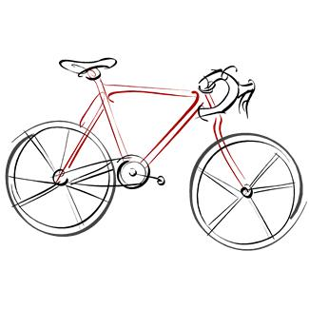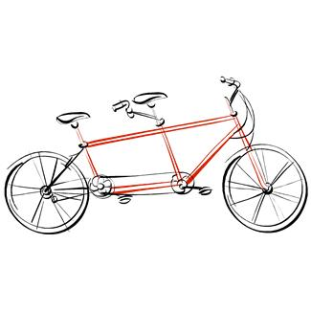

Cyclebag East Ride Programme Summer 2024

Chairman.Sam Swaby Email albertswaby@sky.com
Secretary. Jo Hurst Email johurst@btinternet.com
Treasurer. Brian Baker Email brianalanbaker@hotmail.com
Membership. Patrick Birch Email patrick.birch@virginmedia.com

Meeting Places
Fishponds Fish. The fish structure on the Bristol rail path behind Morrisons at Fishponds
The Winterstream Farm Pub is at the junction of Winterbourne Road and Old Gloucester Road
The Pump House. Pub at the Hotwell Road end of the Harbourside.
Mangotsfield is at the Old Railway Station (Mangotsfield Station) on the Bristol to Bath cycle path.
Coxgrove Hill is where the Yate spur of the Bristol to Bath cycle path meets the bottom of Coxgrove Hill

Day | Date | Leader | Area | Meet | Time | Miles
Sat | 8th June | Ric | To Portbury.....  Clifton Suspension bridge via Portway and up Bridge Valley Road. Coffee at Bike Stop Cafe Abbots Leigh. On to Pill and Portishead. Lunch at Oakham Treasures.  Home via uphill to Failand and down Belmont Hill to Festival Way. Possible stop at M Shed on way home.  3 meaningful hills will be climbed slowly. | Fishponds Fish  Or  Wetherspoons  Temple Quay | 10am  10.20 | 35 miles
Mon | 10th June | Patrick | Moving on tour to Newbury
Sat | 15th June
Sat | 22nd June | Kay | Wrington.  Morning tea Gatcombe Farm.  Lunch Wrington bring your own packed lunch for eating in the churchyard or use village cafe.  A flat route to Congresbury (not the bluebell hill), Backwell and Festival Way to the city. There will be a diversion on the Festival Way in both directions. | Pumphouse, Harbourside. | 10am | Approx  25
Sat | 29th June | Lin | Clevedon | TBC | TBC | TBC
Sat | 6th  July
Sat | 13th  July
Sat | 20th  July
Sat | 27th  July | Chris | Yatton.  Refreshments: Coffee in Coffee #1 Nailsea  Lunch Strawberry Line Cafe, Yatton or option of Yatton Village shops or churchyard  Afternoon comfort stop at Blackhorse pub in Clapton where there is an outside toilet block. | Pump House Pub Harbourside | 10am | About 35 miles loop
Sat | 3rd Aug
Sat | 10th Aug
Sat | 17th Aug
Sat | 24th Aug
Sat | 31st Aug
Fri | 6th Sept  To 12th inc |  | Static caravan holiday.
Please wear bright clothing for your own protection
Please bring lights on all rides, as we can be delayed by punctures, or other unexpected events
Contact Jo with any queries 07941857644 , or by email CyclebagEast@outlook.com

