Triennial Veterans’ Rides 2025 - Organisers’ Guidelines
Tri-Vets rides have been organised by our member groups since Cycling UK’s 50th anniversary year in 1928. They are aimed at people aged 50 and over and take place every three years. Riders have up to 12 hours to complete a 100-mile route. Some groups might choose to also run a 100-km ride to encourage a more diverse range of participants.
The rides are designed to be a fun, social event and should include coffee, tea and lunch stops, with lovely routes taking in pleasant countryside.

The Tri-Vets are a popular social event, with many old friends completing the rides together year after year. Cycling UK is very grateful to all the wonderful volunteers who put time and effort into the Tri-Vets rides, enabling thousands of people to take part in a great day out in like-minded company, completing a personal challenge and enjoying all the benefits of cycling in later life. A big thank you to you all!
Certificates can be awarded to all riders upon completion of the ride – there will be an editable PDF that organisers can download if they wish.
There will also be the opportunity for participants to purchase a commemorative badge and/or date bar in recognition of their achievement. These will be ordered through the ride organisers and distributed after the event (exact arrangements TBC).

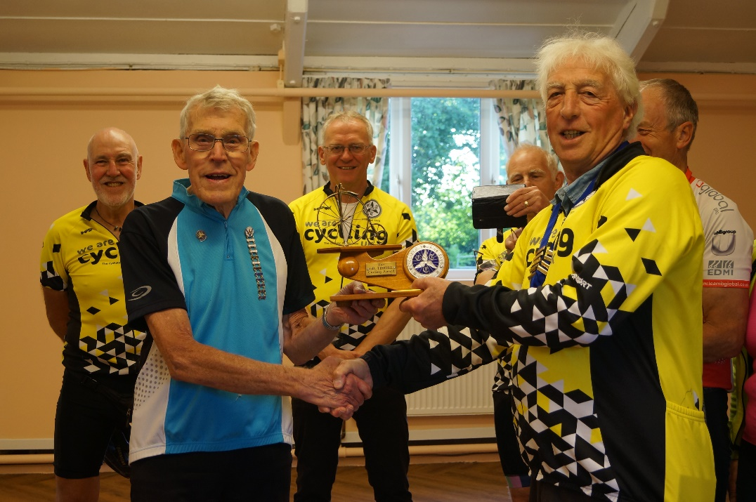
Patrick Hyett completed his 12th Tri-Vets of 100 miles in 2022 aged 86 at
Chester & N Wales/Caer a Gogledd Cymru's 100-mile Tri-Vets ride

- Registration forms and payments will go straight to the club organising the event.
- Tri-Vets events should be run where possible during the months of June and July 2025.
- The entry fee guideline is £16-£18, although some local variation is permitted depending on costs incurred by the lunch and refreshments provided.
- Cycling UK can provide a standard event entry form, which can be adapted to your group’s requirements but should include the disclaimer and a brief description of the route.
- The event can be ridden by Cycling UK members and non-members.
- The event should be registered with Cycling UK via your group’s webpage or a downloaded registration form.
- Tri-Vets badges and date bars may be available to order from Cycling UK National Office and will be distributed to groups to send to participants after the event. Costs TBC but will be approximately £4.50 for a badge and £3 for a date bar.
- Editable certificates can be downloaded for groups to distribute to entrants on the event day.
- Organisers should provide a route sheet, map or GPS coordinates which participants should be able to access before the event and on the day itself.
- The route should not be unduly hard and keep away from busy or main roads where possible.
- A figure-of-eight route can be used if desired, for example:
  - Lunch and tea at the same venue with a 25-mile loop
  - Elevenses and tea at the same venue with a 50-mile loop
- As a guide, plan refreshments every 20-25 miles.
- The start and finish points should, if at all possible, be the same, or in close proximity to avoid unnecessary mileages before or after the ride.
- Some groups choose to lead small groups of riders around the course, with speeds varying according to the ability of the group members.
- Any queries should be addressed to the Cycling UK membership team - membership@cyclinguk.org.
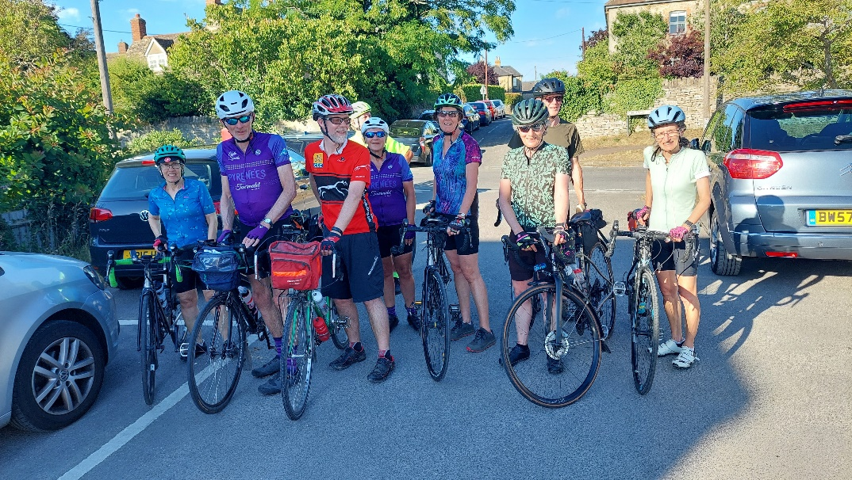  Cycling UK Oxfordshire Tri-Vets 2022 | 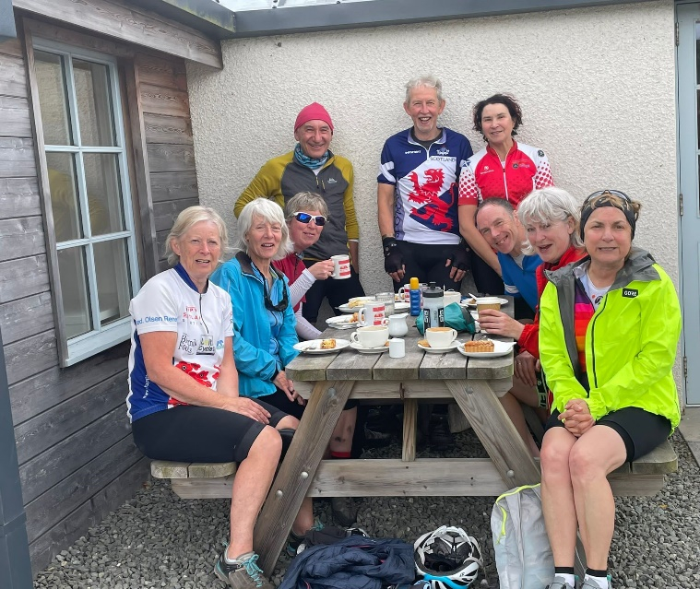  Edinburgh, Lothians and Borders CTC Tri-Vets 2022

