WORKING DRAFT APPLICATION
Please do not send this format to the Cycle Access Fund

Cycle Access Fund - Shared/Individual Expression of Interest

1 | 2 | 3 | 4 | 5 | 6 | 7 | 8
Eligibility  Check | Organisation  Details | Current  Activities | Shared Use  Bikes | Individual  Bike  Ownership | GDPR and  Privacy | Review and  Submit | Complete

Please select the Local Authority where your business/organisation is registered.

Local Authority

NOTE: The Cycle Access Fund is only available in these local authorities
- Aberdeen City
- Aberdeenshire
- Argyll and Bute (only Helensburgh and Lomond District)
- City of Edinburgh
- Clackmannanshire
- East Ayrshire
- East Dunbartonshire
- East Lothian
- East Renfrewshire
- Falkirk
- Fife
- Glasgow

- Inverclyde
- Midlothian
- North Ayrshire
- North Lanarkshire
- Renfrewshire
- Scottish Borders
- Shetland Islands
- South Ayrshire
- South Lanarkshire
- West Dunbartonshire
- West Lothian

Cycle Access Fund - Shared/Individual Expression of Interest

1 | 2 | 3 | 4 | 5 | 6 | 7 | 8
Eligibility  Check | Organisation  Details | Current  Activities | Shared Use  Bikes | Individual  Bike  Ownership | GDPR and  Privacy | Review and  Submit | Complete

Organisation Details

Organisation/Trading Name

Business registered name (if different from organisation name)

Type of organisation

You will get a drop down menu that looks like this:

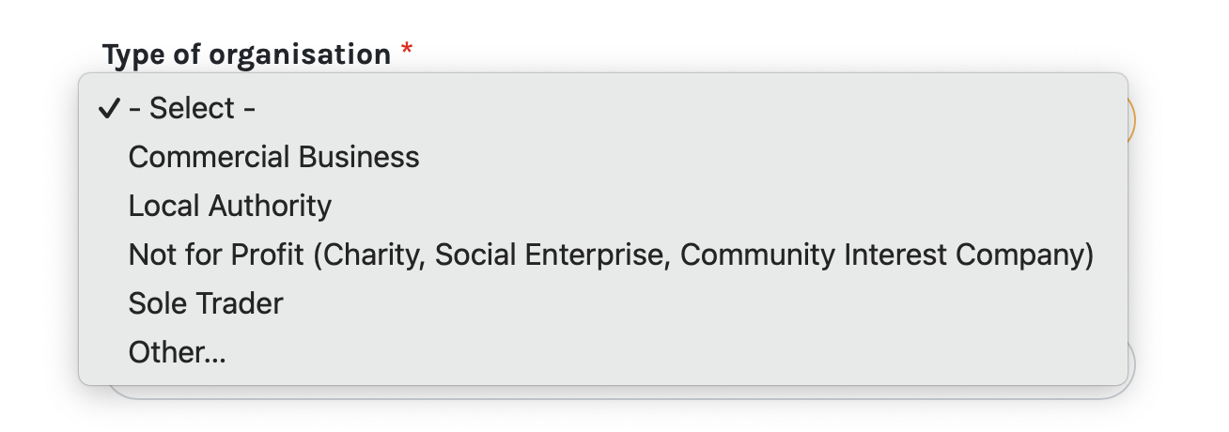

Charity Number (if applicable)

Business Registration Number (if applicable)

Registered Address Line 1

Address Line 2

Town Postcode

Website

Facebook

Instagram Twitter/X

Primary Contact
Primary contact first name Primary contact last name

Primary Email

Primary contact telephone number

Primary contact mobile number

Position/role

Working pattern/availability details
This gives us an indication of when is best to contact to discuss your EOI Submission.

Secondary Contact
The secondary contact will only receive a copy of the EOI submission email. There will be no further emails/contact from us unless we are unable to reach the primary contact for an extended period of time.
Your secondary contact should be someone with seniority within your organisation, a manager, or a board member, where appropriate.

Secondary contact first name Secondary contact last name

Secondary Email

Secondary contact telephone number

Secondary contact mobile number

Secondary contact position/role

Governance & Financial Management
Does your organisation have a safeguarding policy?
Yes No

Does your organisation have public liability insurance?
Yes No

Please upload your governance documents (e.g. your Memorandum and Articles of Association, Constitution).
If you are applying from a local authority or educational establishment, please provide evidence that you have a cost centre or verify your means to receive funding for this project. (e.g. letter from your finance department)
Cycle Access Fund - Shared/Individual Expression of Interest

1 | 2 | 3 | 4 |  | 5 |  | 6 | 7 | 8
Eligibility  Check | Organisation  Details | Current  Activities |  | Shared Use  Bikes |  | Individual  Bike  Ownership | GDPR and  Privacy | Review and  Submit | Complete

Tell us about the work your organisation does.
We would like to understand how your application for funding fits into your current range of services or activities.

Where applicable, give details of services and actvities you provide (e.g. Wellbeing activities, finance advice, food bank, etc.) and outline how you monitor and evaluate the impact of your work.

Minimum 50 words

The online form will show your word count below the box

Number of staff

Number of volunteers

Cycle Access Fund - Shared/Individual Expression of Interest

1 | 2 | 3 | 4 | 5 | 6 | 7 | 8
Eligibility  Check | Organisation  Details | Current  Activities | Shared Use  Bikes | Individual  Bike  Ownership | GDPR and  Privacy | Review and  Submit | Complete

NOTE: If you are applying for the Individual Bike Ownership stream, skip to that section (5).

In this section you are asked for details of your proposed programme for shared cycle use.

Your Shared Use Cycle Project
Are you seeking funding to create a new cycle loan project or to expand a cycle loan project you already operate?
New
Expansion

Please outline how you plan to spend the funding.

Minimum 50 words

The online form will show your word count below the box

How you will monitor the project's impact?
You will be aware from the guidance that we require a brief form to be submitted after each cycle use. Please detail how you will ensure this is done.

Minimum 50 words

The online form will show your word count below the box

How does your proposed project meet a particular need in your community?
Successful applicants will demonstrate that their project promotes inclusivity and tackles inequality. Please outline how your project will do this, using data and evidence where possible.

Minimum 50 words

The online form will show your word count below the box

How do you plan to manage the loans?
E.g. personnel, processes, cyclist competence/training needs, covering the ongoing maintenance costs etc.

Minimum 50 words

The online form will show your word count below the box

Over a period of 3 years, approximately how many people do you expect to reach with the cycles bought through this fund?

Funding Detais
Approximately, how many cycles would you like to purchase?

Do you have a bike shop in mind?
Yes
No

NOTE: If you answer Yes you will be brought to this question

Please provide the name of the bike shop(s).

What type(s) of cycle will you purchase?
Please select all that apply.

standard bike
standard e-bike
non-standard bike (cargo, trike, side by side, etc.)
non-standard e-bike (cargo, trike, side by side, etc. with electrical assist)
child's bike

Please outline why you think these bikes will be best for your scheme.

Minimum 20 words

The online form will show your word count below the box

Will you be requesting funding for storage?
Yes
No

NOTE: If you answer Yes you will be brought to this menu

Please tell us about your proposed storage site.
Please select all that apply. If you would like to add more information, please also select additional details

Permission for use not yet sought
Permission for use sought
Permission for use granted
Groundworks required
Site ready for use
Site not yet ready
Additional details/Other

NOTE: If you answer No you will be brought to this question

What storage do you already have?
Please tell us about storage you already have in place for your bikes and accessories. Include information about the location, type of storage, security and access.

Cycle Access Fund - Shared/Individual Expression of Interest

1 | 2 | 3 | 4 | 5 | 6 | 7 | 8
Eligibility  Check | Organisation  Details | Current  Activities | Shared Use  Bikes | Individual  Bike  Ownership | GDPR and  Privacy | Review and  Submit | Complete

In this section you are asked for details of your proposed programme for individual bike ownership.

This fund is to support adults who are struggling financially, so you should specify how your project will do this.

Your Individual Bike Ownership Project
Please outline how you plan to spend the funding.

Minimum 50 words

The online form will show your word count below the box

How have you identified bike recipients?
We expect you to identify bike recipients at this stage to ensure individuals receive the correct bike.

Minimum 50 words

The online form will show your word count below the box

How will you support bike recipients to use their cycles?
E.g. training, maintenance, etc.

Minimum 50 words

The online form will show your word count below the box

Please give details of how participants will engage with your organisation after they have received a cycle.
We require you to have ongoing and meaningful contact with bike recipients to support our monitoring and evaluation: give details of how participants will engage with your organisation after they have received a cycle

Minimum 50 words

The online form will show your word count below the box

Funding Details
Approximately, how many cycles would you like to purchase?

What type(s) of cycle will you purchase?
Please select all that apply.

*We will only consider purchasing e-bikes where there is a mobility need, health condition or disability
standard bike
standard e-bike*
non-standard bike (e.g. trike)
non-standard e-bike* (e.g. trike with electrical assist)

Would you like us to introduce you to a bike shop to help you choose the right bikes for your participants?
Yes
No

If you answer No you will be brought to this question

Please provide the name of the bike shop(s) you have in mind.

Cycle Access Fund - Shared/Individual Expression of Interest

1 | 2 | 3 | 4 | 5 | 6 | 7 | 8
Eligibility  Check | Organisation  Details | Current  Activities | Shared Use  Bikes | Individual  Bike  Ownership | GDPR and  Privacy | Review and  Submit | Complete

GDPR Compliance
Privacy policy

Cycling UK (“we”, “us”, or “our”) is committed to protecting and respecting the personal and organisational data that we hold. If at anytime you would like to remove any data, please contact: cycleaccessfund@cyclinguk.org If you have questions about our policies please contact Cycling UK’s
Data Protection Officer: dpo@CyclingUK.org. A full copy of our Privacy and Data Protection Policy can be found at www.cyclinguk.org/privacy-policy.

You must comply at all times with all data protection legislation applicable in the UK. Read more at cyclinguk.org/privacy -policy.
I confirm I have read and agree to Cycling UK's privacy policy.

Cycle Access Fund - Shared/Individual Expression of Interest

1 | 2 | 3 | 4 | 5 | 6 | 7 | 8
Eligibility  Check | Organisation  Details | Current  Activities | Shared Use  Bikes | Individual  Bike  Ownership | GDPR and  Privacy | Review and  Submit | Complete

You are now ready to submit your application.

If you would like to review your details prior to submitting, please navigate back through the form using the Previous and Next buttons.
When you are ready, please submit via the button below.

If your application has been submitted successfully, you will be shown a confirmation message.
You will also receive an email containing a PDF version of your submitted application.

