A guide to promoting your Member Group with Cycling UK

Logos and branding
In April 2016, CTC rebranded as Cycling UK. We would like all groups to adopt the new branding and grow with us, staying connected to each other as part of a strong network of cycling groups. The logos, along with brand guidelines can be downloaded from our website. Please add the brand to your website and other social media so it can be seen as widely as possible.

EXAMPLE 1

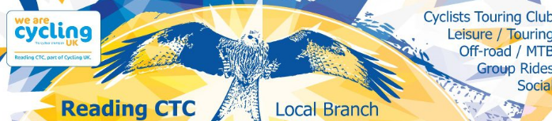

Using the existing name of Reading CTC, the group has incorporated our new logo, making it clear it is part of the new Cycling UK brand.

EXAMPLE 2

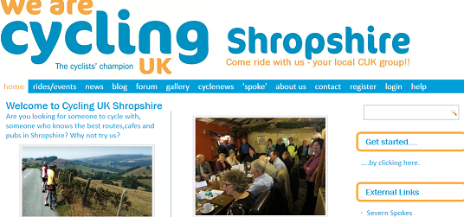

This group has rebranded completely to become Cycling UK Shropshire and has fully adopted the new logo, branding and font on its website. (Although please don’t abbreviate Cycling UK!)

Facebook:
Facebook is a good organisational tool, as well as a way of communicating with existing and future riders. Many people will try and find a local group on Facebook so keep your page up-to-date and relevant with news about your rides and events, links to interesting articles on cycling topics plus lots of photos of your rides.

How to use Facebook:

- Set up an account in your own name using your email address. (This does not have to be a ‘real’ account if you’d prefer not to be ‘found’ on Facebook.)

- Next, set up a page for your cycling group through this account.
Only you will be able to manage the page and post from the page but other people will see the posts under the page name rather than your name.

- Make a public Facebook page not just a private group!
A public Facebook page is more accessible; everyone can see what is posted, rather than just the people who have access to the group. If someone interested in cycling in Rochdale, for example, wants to find a cycling group, they’re more likely to find a cycling Facebook public group page than a private Facebook group.

- Call your page something obvious and simple, like ‘Cycling UK Rochdale’, or a name people are likely to search for. Think about what you would type in if you were searching for your nearest cycling group.

- Anyone who ‘Likes’ your page will get updated on what you’re posting via their newsfeed.

- From your Facebook page, you can:

- Create an event or group. Do this by clicking the ‘Events’ tab under ‘More’ and then clicking ‘Create an Event’.

- When you’ve created the event, people have the option to click ‘Attending’. When someone clicks ‘Attending’, their Facebook friends can see that they are attending the event in their newsfeed. This means people who know about your group and attend your events effectively do some promotion for you!

- Tag Cycling UK by using @CyclingUK so we can share it too.

EXAMPLE 1
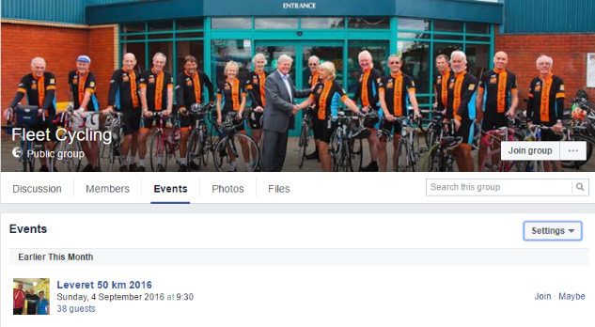

A nice example of a Facebook page from Fleet Cycling with a colourful profile picture and an event created for people to join in with.

EXAMPLE 2
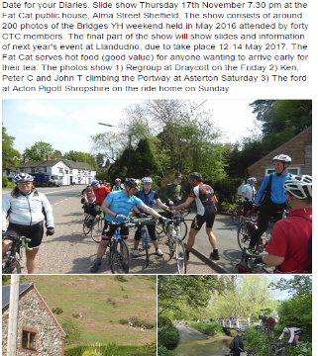

Another nice Facebook post - it gives more information than on Twitter or Instagram and includes some nice shots of an event.

Twitter
Twitter isn’t as in-depth as Facebook as you can only post 140 characters per post but it’s great for updates and links. It’s particularly good for current information and for publicity during an event:

How to use Twitter:

- Create hashtags for your group:
Creating a hashtag is as simple as putting the hashtag symbol in front of a word or phrase i.e. #cycling. If you click on the hashtag it will show all the other tweets using the same one so you can find people interested in the same thing. The more unique your hashtag, the more specific to you and your followers it is but the more generalised it is, the more widespread it will be and it’s more likely more people will see your tweet from clicking on the hashtag on another tweet. You can even use multiple hashtags per tweet.

- Tweet before and during events:
Tweet in the days or weeks before an event so people following you get reminders in their newsfeed. Tweet during the event to give live updates to people not at the event to encourage them to come along next time! You could even use a hashtag on these tweets like #livecycling #livetweeting.

- Follow people:
Follow people or companies interested in similar things. When you follow someone, they’ll get a notification and are likely to click on your Twitter to see who you are and what you’re about. If they’re also interested, they’re likely to follow you back. Once they’re following you, they’ll see your tweets regularly! You can follow Cycling UK by tagging @WeAreCyclingUK.

EXAMPLE 1

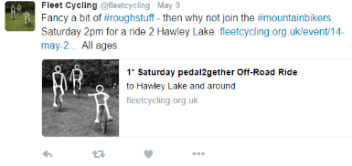

A good example of a tweet. It uses a relevant event-based hashtag and includes a link for more information and an eye-catching image. Concise and informative.
EXAMPLE 2

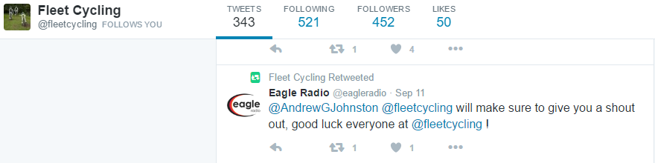

This tweet shows how you can spread your message further by retweeting a local radio station and therefore reaching a much wider audience.

Instagram:
Instagram is predominantly pictures and many young people are addicted to Instagram and posting ‘selfies’ and so on but you can use it to make your cycling look brilliant, and there’s filters and editing tools to enhance your images.

How to promote through Instagram:

- Post photos after events: typically, Instagram is good for posting one or two photos at a time and really choosing the best one, Facebook is the place for posting entire photo albums. Make your photos look lovely and really show what cycling is about to your group.

- You can use hashtags to gain attention, this time using generalised hashtags like #cycling #uk #roadcycling #countryside is best because they will attract people to ‘like’ your photo. The more ‘likes’ you get, they more people are likely to see your photo.

EXAMPLE 1

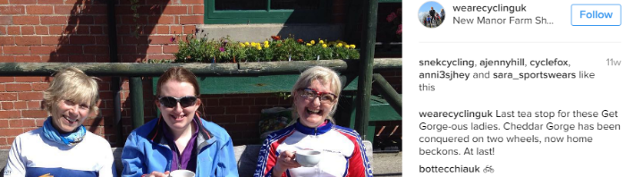
EXAMPLE 2

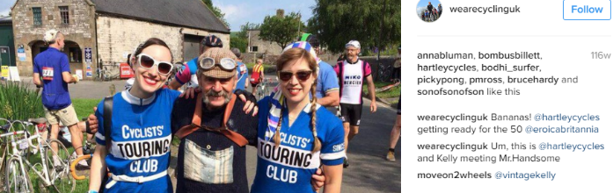

A good example of an Instagram image from Cycle UK’s Instagram (@wearecyclinguk). Nicely-framed, creatively shot and looks exciting. Instagram is about being more creative with your photos, rather than the standard group shot.

- E-newsletters:
E-newsletters are good for people not on social media as they only need an email account to receive them (BUT bear in mind any junk mail suppressions or Data Protection issues and ONLY use BCC (Blind Carbon Copy) and/or an email provider such as MailChimp or similar. One email a week should be enough to update people on what’s been happening, promote particular events or remind members about forthcoming rides.

How to promote through E-newsletters:

- Attach your events and news
Write about what’s going on and how to get involved.

- Add your social media handles on the bottom of the email:
Tell your readers that they can find out more on your Facebook/Twitter/Instagram and try and get them involved.

Below are extracts from a weekly e-newsletter by a group from Sheffield. It shows their events coming up this week and how to sign up and get involved in a simple, clear way.

EXAMPLE 1

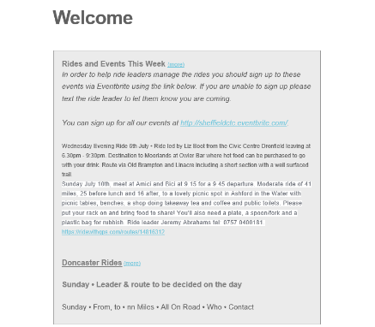

EXAMPLE 2
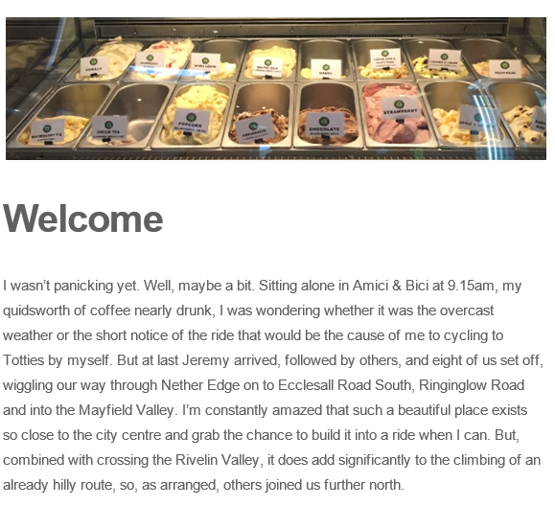
This email has a lovely chatty tone and enticing pictures of cakes or ice-cream always go down well!
How to take good photos for using in social media:

- Think about composition:
The rule of thirds is great for any photo, imagine a grid over your image and make sure that the points of interest in the photo either fall on a line or in a box, the horizon should be on the top of bottom line depending on your vantage point. Make sure that you don’t have excess empty space in the image (i.e. grass or sky), fill the frame with people and bikes.

- Think about diversity:
Does your photo look as though the group is only for women or only for 50+? Make sure the photo shows that the rides are accessible and open to all.

- Make it exciting:
Although photos of the entire group include everyone and enhance diversity, they don’t always represent the action of cycling. Go for individual shots with wonderful countryside or shots of small groups talking or laughing and not necessarily looking at the camera, people caught off-guard or naturally having fun make for better photos.

- Take more:
The benefit of technology, you have endless opportunity to get that perfect shot. Take more photos, you can always delete them if they’re not up to scratch.

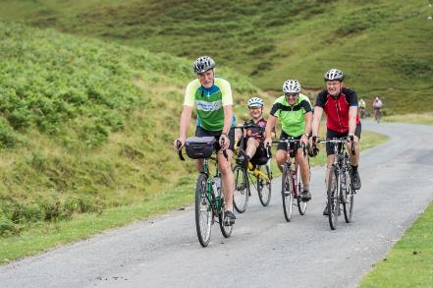

A great example of the rule of thirds, which also shows people having fun.

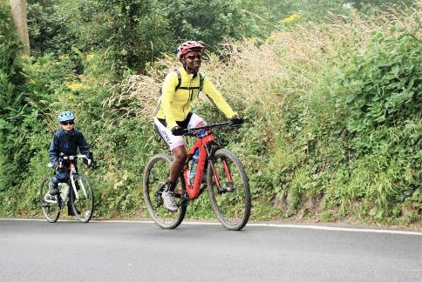

Another good example of the rule of thirds which also shows that cycling can be accessible for children.

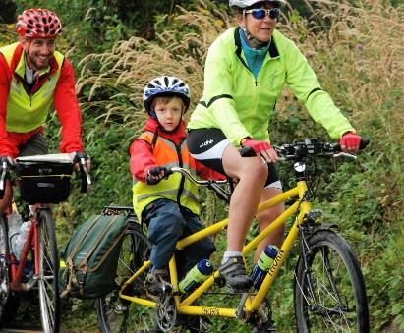

A diverse group with a good focal point, the frame is well-filled and there’s no excess space.

Send us photos of your ride using the hashtag #CyclingUKGroups on Facebook, Instagram or Twitter after following this toolkit – your group may be featured in CycleClips!

Top tips to be social media savvy:

Writing posts across social media:

- Be brief:
Don’t write about every tiny detail, only write about what’s really important.

- Be informative:
Draw your reader in and pick what you tell them carefully, you want them to be engaged and interested by what you’re saying so that they’ll come back time and time again.

- Add to your photos, tell us what we can’t see:
Steer away from describing the photos and add to what you know and saw beyond the image.

- Hashtags:
Hashtags work across all social media, you can use them across Facebook, Twitter, Instagram. Make them specific to you but not so specific that people won’t think to search them i.e. #groupcyclingmarch2016 is too specific but #cycling is very generalised and will have been used millions of times.

- Combine your social media:
In the description boxes, add your names and tags on other forms of social media. I.e. In your ‘About’ box on Facebook, write ‘follow us on Twitter: @_______, Instagram: @________’ to connect your media outlets together.

- Be consistent:
Promote the same events across all your social media so everyone will see them, even if they only have Twitter.

How to promote your rides and events through Cycling UK

Cycling UK offers a full support service for cycling groups so that they can reach the widest possible audience and we have a variety of ways that you can use us to promote you.
- Homepages

We have created homepages for all our groups that can be personalised with information about your rides, events and other activities. To be able to do this, you need to be an admin or manager for the page. Instructions on how to do this can be found in Help for group homepages. If you’re not sure if you’re an admin or manager, contact Cycling UK.

EXAMPLE

CTC Ayrshire
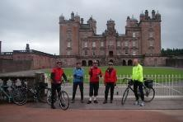
About The Group
The Ayrshire section of CTC covers three counties, resulting in an area some 60 miles long by 30 miles wide before the inclusion of the island of Arran.
Catchment area
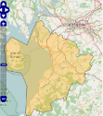

About our rides
Each month the club organises a number of different runs which are designed to suit all tastes. On the second Sunday of each month we host our main run of around 40-60 miles, and on the last Sunday of the month an easier run of around 25 miles. Ayrshire CTC places the emphasis on leisure and social cycling and strives to ensure that all participants in our cycling programme are well supported by fellow cyclists to get the most enjoyment from their bikes and our lovely countryside.
- Events Listing
We have a list of all Cycling UK events on our homepage, which has over 100,000 unique visits a month. We would love all our groups to add their rides and events to this list to show the wide variety of activities we support, enabling more people to experience the joy of cycling.
EXAMPLE
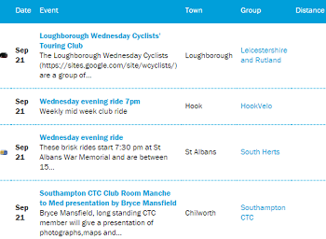
To add your regular rides and events to this list, go to your group homepage, then click on Create a ride or event – remember that you will need to be an admin or manager on your group’s page to be able to upload events. Contact Cycling UK if you are not sure whether or not you are listed as such for your group.
Other ways you can promote your cycling group through Cycling UK:

- Write to us to get your events/rides included in CycleClips or ClubShorts and/or in a feature on our website and other social media – email publicity@cyclinguk.org. Perhaps you have a particularly interesting anniversary or group event coming up or a group holiday that was memorable in some way that other members would like to read about?

- Write to the editor to suggest a feature in ‘Cycle’ magazine eg Travellers’ Tales. Email: editor@cyclinguk.org

- Send us your own publications whether in paper or electronic format so we can see what you’ve been up to and then tell the rest of the cycling world. Post to Member Group Coordinator, Cycling UK, Parklands, Railton Road, Guildford, GU2 9JX.

- We have a range of marketing materials you can use to promote your group at shows and other local events. These include an editable PDF poster that you can customise with your group’s details etc.

Finally, we are always delighted to help with promoting your group so don’t hesitate to get in touch with either Julie Rand or Mark Slater to find out how we can assist.

